COMP8430: Advanced Computer Vision and Action
Major Project Phase 4: Project Presentation and Report
Fine-Tuning and Evaluation for Robot-Based Fruit Classification
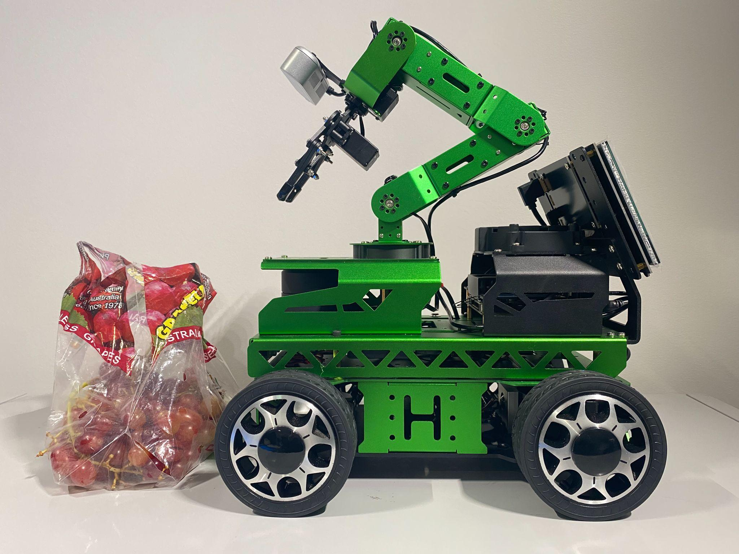
MEMBERS OF GROUP 3:
# | Student Name | Student ID
1 | Phuong Thao (Jasmine) Huynh | 46248722
2 | Prakhar Mishra | 48081906
3 | Taha Naveed Shibli | 47892641
4 | Gary Tze Hay Lau | 45245673
Table of Contents
1. INTRODUCTION | 2
2. OBJECTIVE AND SCOPE | 2-3
3. SYSTEM DESIGN AND METHODOLOGY  3.1 Data Source and Synthetics  3.2 Large Language Model Training and Deployment  3.3 Chatbot Architecture | 2-3
4. EVALUATION STRATEGY  4.1 Quantitative Metrics  4.2 Human Evaluation | 4-5
5. RESULT AND ANALYSIS  5.1 Quantitative Results  5.2 Human Evaluation Result  5.3 Additional Profiling and Training Analysis | 5-7
REFERENCE | 8-9
APPENDIX A: SUPPLEMENTARY MATERIALS | 10-22
APPENDIX B: PROJECT TIMELINE & TEAM CONTRIBUTIONS | 22-23


1. INTRODUCTION
This report concludes our fine-grained fruit classification project by documenting the final system developed and deployed across Phases 1 to 3. In this final phase, our focus shifted from implementation to formal presentation and technical reporting. Building on previous work involving dataset collection, model development, and robotic deployment, we consolidated our findings into a structured presentation and this comprehensive report.
The report summarizes the selection of target fruit classes, the preparation of robot-captured datasets, model fine-tuning strategies, and system performance under real-world conditions. It also reflects on the system’s strengths and limitations, and outlines each member’s contributions. The goal is to communicate our end-to-end approach clearly and professionally to a technical audience familiar with advanced image classification techniques, as expected in COMP8430.

2. GROUP DATASET OVERVIEW AND 3 CLASSES SELECTION
To build a robust fine-grained fruit classification system, our group merged individual datasets collected in Phases 1 and 2, resulting in a comprehensive set of 2,014 high-resolution images across 21 fruit classes. Each team member contributed data across apples, grapes, pears, bananas, and oranges, capturing diverse lighting conditions, angles, and device types to enhance model generalization.

2.1 Dataset Summary and Team Contribution
The dataset is reasonably balanced, with most classes containing 80–115 images. Grapes and apples dominate the distribution, accounting for 27.6% and 36.5% respectively. Jasmine contributed nearly half the dataset (48.2%), with other members contributing evenly across all categories, as visualized in the dataset heatmap. All images were standardized to JPEG format at 224×224 resolution using a preprocessing pipeline that handled conversion, resizing, and filename normalization.
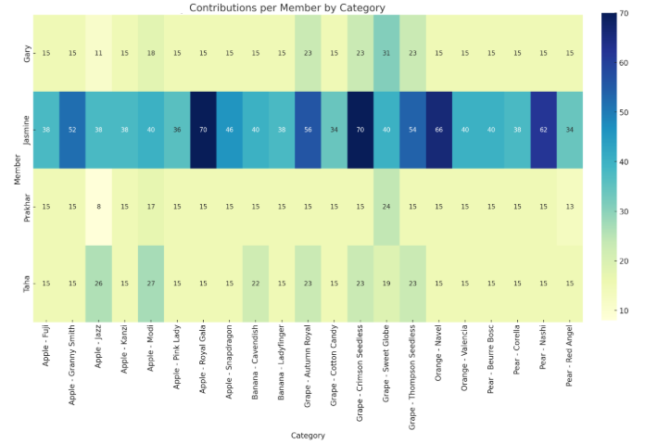

2.2 Class Selection for Robot Deployment
For deployment in Phase 3, we selected three visually similar grape classes: Crimson Seedless, Thompson Seedless, and Autumn Royal. These varieties were chosen due to their high intra-class similarity, balanced representation in our dataset, and consistent inclusion across all members’ contributions in Phases 1 and 2. Notably, Thompson Seedless had shown frequent misclassification in earlier experiments, making it an ideal candidate to test the impact of domain-specific fine-tuning using robot-captured images. In addition, all three grape varieties were readily available in local supermarkets throughout summer to winter, ensuring practical accessibility for repeated testing and real-world deployment.

3. IMAGE CAPTURE USING ROBOT HARDWARE
To classify grapes in a real-world setting, we built upon our ROS2 nodes from Practical Week 8, creating a modular image capture and classification pipeline. Instead of continuous frame capture, we implemented an on-demand system, triggered by keypress. This gave us better control over image quality, reduced redundant frames, and simulated deliberate image selection.
We collected images of Crimson Seedless, Thompson Seedless, and Autumn Royal grapes with the robot's camera, mounted at chest height. To simulate real-world conditions, we varied lighting (lab, natural, LED) and backgrounds (trolley, desk, notebook, packaging). Manual robot positioning and a handheld flash further diversified the visuals. After filtering, each grape class had at least 45 usable images.
We also streamlined movement integration by having inference.py directly publish servo commands based on grape classification. This allowed the robot to make real-time arm gestures. We used two terminals for image capture and inference to maintain modularity and stability.
In total, 165 robot-captured images were collected. The dataset was split into 70% for fine-tuning and 30% for testing, with balanced representation across the three grape classes. This partitioning strategy provided a reliable basis for assessing the model’s performance in the robot’s deployment environment and allowed targeted adaptation to hardware-specific conditions.
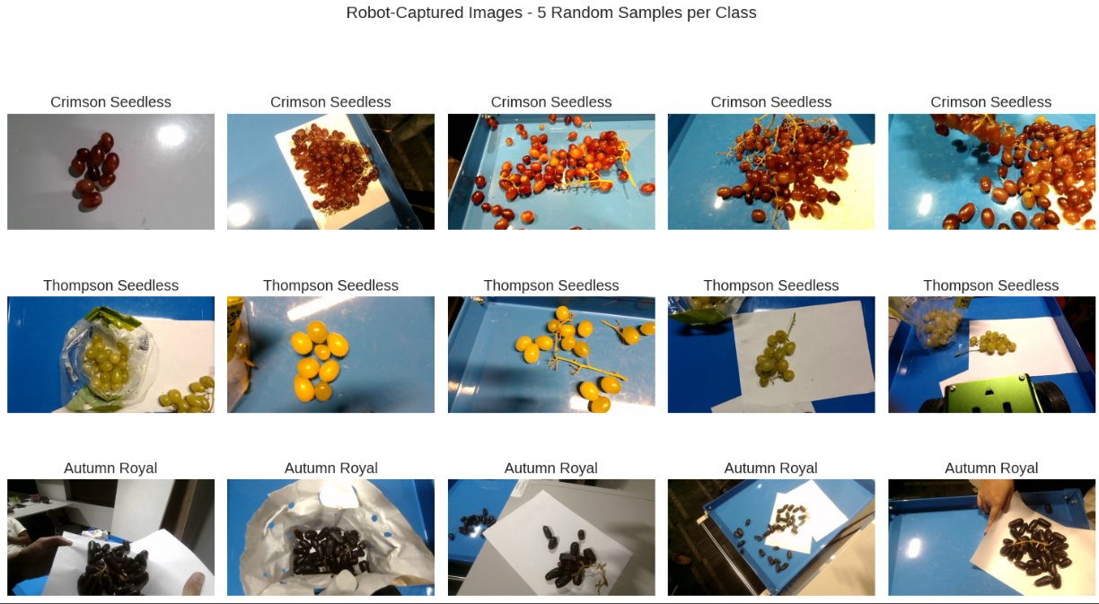

Class | Total | Fine-TuningSet (≈70%) | Test Set (≈30%)
Crimson Seedless Grape | 57 | 39 (68.4%) | 18 (31.6%)
Thompson Seedless Grape | 53 | 37 (69.8%) | 16 (30.2%)
Autumn Royal Grape | 55 | 38 (69.1%) | 17 (30.9%)
Total | 165 | 114 (69.1%) | 51 (30.9%)

4. MODEL SELECTION AND FINE-TUNING
4.1 Classifier Choice and Rationale
To determine the most suitable classifier for Phase 3 deployment, we evaluated the performance of each team member's models from Phases 1 and 2. The group’s final decision was based on a comparative analysis of key performance metrics, alongside considerations of practical deployment constraints.
The summary of each member’s best-performing model and configuration is presented below:
Member | Explored Models | Best Model & Configuration
Jasmine | DenseNet-201, EfficientNet-B0 | EfficientNet-B0  • Partial fine-tuning, no data augmentation  • 99.28% test accuracy  • Inference time: 3.09 ms/image  • Model size: 15.68 MB
Prakhar | ResNet50, ViT | ResNet-50  • Partial fine-tuning (final ResNet-50 layer unfrozen)  • StepLR learning rate schedule  • Moderate data augmentation: random resized crop, horizontal flip, colour jitter, ImageNet normalization  • 95.83% test accuracy
Taha | RestNet50, VGG-16 | ResNet-50  • Partial fine-tuning (layer4 and layer3 unfrozen)  • OneCycleLR scheduler  • Extensive data augmentation: resize, horizontal flip, rotation, perspective, affine, color jitter, grayscale, random erasing, normalization  • 75.22% test accuracy
Gary | EfficientNet-B0, EfficientNet-B4 | EfficientNet-B4  • Partial fine-tuning (final block unfrozen)  • LambdaLR scheduler with exponential decay after epoch 8  • Moderate data augmentation: resize to 448×448, horizontal flip, rotation up to 26°, color jitter (brightness=0.11, contrast=0.12, saturation=0.09, hue=0.08), ImageNet normalization  • 75.44% test accuracy

Across all experiments, EfficientNet-B0 emerged as the most effective model for our task. With only 5.3 million parameters and 0.39 billion FLOPs, EfficientNet-B0 achieves a strong balance between computational efficiency and accuracy, making it highly suitable for deployment in resource-constrained robotic systems. Its success also relies on its compound scaling design - balancing depth, width, and resolution for robust feature learning. Additionally, its support for transfer learning via pre-trained ImageNet weights enables strong generalization, even with limited domain-specific data or images with subtle visual differences, as in our case with robot-captured grape images.
Notably, the relevance of EfficientNet-B0 for fruit classification tasks has been demonstrated in prior research. Duong et al. (2020) reported 99.97% accuracy using EfficientNet-B0 on the Fruits-360 dataset, outperforming conventional CNN architectures. This strong empirical foundation, coupled with our own Phase 2 results, where Jasmine’s EfficientNet-B0 model achieved the highest test accuracy of 99.28%, reinforced our decision to adopt EfficientNet-B0 as the core model for Phase 3 deployment.
4.2 Fine-Tuning - Combined Dataset vs Robot-Captured Dataset
The fine-tuning process was conducted in two stages.

In the first stage, we fine-tuned EfficientNet-B0 on the full merged dataset containing all 21 fruit classes. In the second stage, we fine-tuned it only on the three selected robot-captured grape classes: Grape – Crimson Seedless, Grape – Thompson Seedless, and Grape – Autumn Royal. In both stages, the evaluation was done on just the three classes. The fine-tune set contains 114 images, out of which 96 images were used for training, 18 for validation, and 51 total images were reserved for testing.

Our objective was to compare the model’s performance when fine-tuned on the three selected classes against the model fine-tuned on all our 21 classes.

For the first stage, the evaluation results reveal mixed outcomes.
- Overall accuracy across all three classes was 0.51, indicating moderate transferability of the model from the general fruit dataset to the robot-specific data domain.
- Per-class performance varied significantly. As shown in Figure 8, the model achieved perfect accuracy on Autumn Royal; but performed only moderately on Crimson Seedless with 0.50 accuracy. However, it completely failed to classify Thompson Seedless correctly, with an accuracy of 0.00.
- The confusion matrix in Figure 9 better explains the misclassifications. Thompson Seedless grapes were consistently misclassified as Cotton Candy and Sweet Globe, reinforcing the challenges of fine-grained fruit classification under real-world variations. In contrast, the model correctly classified most Autumn Royal samples, while Crimson Seedless exhibited a moderate degree of confusion.
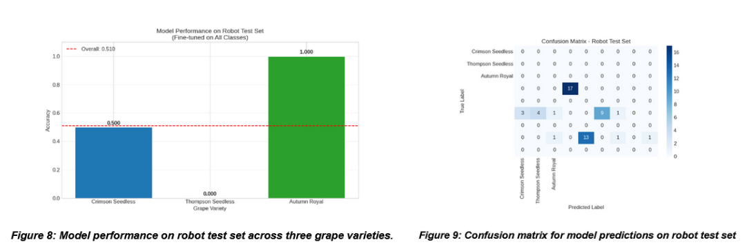
In the second stage, after fine-tuning the model on the three robot-captured grape classes, we observed the following results:
- This model showcased significantly better performance, with an accuracy of 98.04% (50/51 correct classifications).
- Unlike before, Thompson Seedless was classified perfectly (1.00). Only one Crimson Seedless grape was misclassified as Autumn Royal, most likely caused by a glare present in the image.
- Overall, we observed a remarkable improvement of 92.31%; reinforcing the belief that domain-specific fine-tuning exhibits better generalisability.
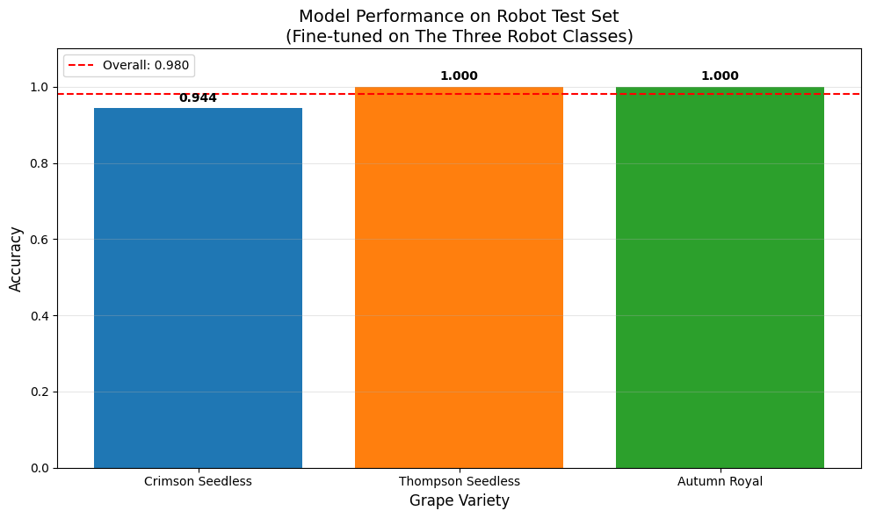
Figure 10: New model’s performance on robot test set across three grape varieties.

5. DEPLOYMENT AND ROBOT BEHAVIOR
5.1 Deployment Setup & To Control the robot
Our robot system uses capture_sub.py to get real-time fruit images. inference.py then processes these using our EfficientNet-B0 model (from model.wrapper) to detect and classify fruits. If a fruit's confidence score is above 0.75, the robot automatically performs the necessary arm movements. This system is built on ROS2 (Robot Operating System 2), which enables different robot components to communicate. We use rclpy (ROS Client Library for Python) to create the robot's node, manage camera image subscriptions, and send movement commands for its wheels and arm.
To control the robot's base (wheels), the program uses geometry_msgs.msg's Twist message for forward, backward, and turning movements. For the robot's arm, it uses custom ServosPosition and ServoPosition messages from ros_robot_controller_msgs.msg to control arm part positions and movement durations.
The robot uses its camera to understand the world. Sensor_msgs.msg.Image captures camera feeds in a ROS format, which CvBridge then converts for computer vision libraries. To process the images and detect the type of grape, the program uses PyTorch, a deep learning framework. PyTorch powers the object detection, loading a fine-tuned EfficientNet-B0 model trained to recognize three grape types. After image preprocessing (using torchvision), the model makes a prediction.
The image_callback function continuously processes these incoming images. Once converted by CvBridge and transformed into a PyTorch tensor, the EfficientNet-B0 model analyzes the image, yielding a prediction and confidence score. If this score exceeds 75%, the robot automatically initiates a specific robotic arm movement tailored to the detected grape type. Threading allows users to start/stop robot actions via the Enter key.
5.2 Action Mapping Design
Our robot's inference system uses servo motors to trigger unique arm movements for each grape type detected by the EfficientNet-B0 model. This ensures clear, distinguishable responses.
Here's how the servos work:
- Servo ID 1 controls the circular base, allowing horizontal rotation (left-right movement);
- Servo ID 2 controls the base joint, moving the arm vertically (up-down) from the base;
- Servo ID 3 controls the elbow joint, designed to vertically extend or curl the arm.
- Servo ID 4 vertically controls the hinge that holds both the claw and the camera.
- Servo ID 5 controls the horizontal position of the claw; and
- Servo ID 10 opens or closes the claw.
Upon grape classification by the EfficientNet-B0 model, the robot's arm performs a distinct gesture using specific servo angle values. These arm gestures are summarized as follows:
Class | Grape Type | Arm Motion (Servo ID: Position) | Purpose
0 | Autumn Royal | 1: 900 (left)  2: 650 (low)  3: 50 (curled)  4: 500 (tilted down)  10: 500 (half-open) | Low leftward reach
1 | Crimson Seedless | 1: 500 (middle)  2: 500 (middle)  3: 500 (middle)  4: 500 (middle)  10: 100 (open) | Straight upward extension (neutral)
2 | Thompson Seedless | 1: 100 (right)  2. 650 (right)  3: 50 (curled)  4: 500 (tilted down)  10: 500 (half-open) | Low rightward reach

6. DISCUSSION AND ANALYSIS

6.1 System Adaptability and Domain-Specific Learning
Phase 3 marked the successful end-to-end deployment of our fruit classification system in a real robotic setting. This achievement was built upon the foundation laid in Phases 1 and 2, where each team member developed deep learning models and gathered diverse datasets covering 21 fruit classes. This collective effort not only informed our model selection but also enabled us to fine-tune EfficientNet-B0 specifically for the deployment environment. The result was a smooth transition from controlled testing to real-world use, with our model adapting quickly to the new domain of robot-captured images.
After fine-tuning on robot-specific data, EfficientNet-B0 achieved a test accuracy of 98.04%, a significant jump from the 51% it reached without domain adaptation. This improvement highlights the importance of aligning training data with deployment conditions, especially in visual recognition tasks where lighting, perspective, and background can vary greatly. Although our data collection involved careful manual framing, it occasionally introduced slight mismatches with the robot’s fixed-camera setup. This revealed a key lesson: to ensure reliability in real-world deployment, training must closely replicate operational conditions.

6.2 Achievements and Limitations
One of the major accomplishments of this phase was the seamless integration of visual recognition and robotic actuation into a functioning real-time system. The robot was able to classify images captured by its onboard camera and execute arm movements based on the identified grape type. This demonstrated the model’s practical applicability in a real-world setting and proved the feasibility of deploying deep learning models on hardware-limited platforms. Additionally, the direct mapping of classification results to robot actions added a layer of transparency to the system’s decision-making, which is a vital attribute for trustworthy autonomous systems.
The strong performance of the system can be attributed to the methodical model selection and evaluation process conducted in earlier phases. By comparing multiple architectures like ResNet, DenseNet, and EfficientNet, we identified EfficientNet-B0 as the most suitable candidate, offering an ideal balance between accuracy, model size, and computational efficiency. Its compact nature and reliable performance made it well-suited for deployment on a constrained robotic setup, affirming the importance of early experimentation and empirical benchmarking in achieving robust outcomes.
However, some challenges persisted. Thompson Seedless grapes, due to their high visual similarity with other grape classes, were more prone to misclassification, especially under inconsistent lighting or glare. Although domain-specific fine-tuning improved accuracy significantly, occasional errors remained.. These misclassifications highlighted the need for a more diverse training dataset that captures a broader range of lighting, angles, and real-world noise. Technical limitations also impacted our workflow; frequent ROS 2 rebuilds after minor code changes disrupted development, and limited battery life reduced testing time. These constraints ultimately slowed down progress, underscoring how practical engineering challenges can influence both the pace and reliability of applied AI research.
6.3 Reflection and Future of Work
Reflecting on this phase highlights the real-world complexities of deploying machine learning systems outside the lab. Our experience showed that success goes beyond selecting a high-performing model; it requires aligning training strategies, data collection, fine-tuning processes, and deployment conditions. The final system’s reliability was not just a product of technical capability, but also of careful planning and iterative testing. Just as important was the collaborative effort behind it. Shared responsibilities, peer feedback, and joint problem-solving played a central role in overcoming challenges, especially those tied to the robot’s hardware limitations and the constraints of the ROS 2 development workflow. This teamwork allowed us to move quickly through technical setbacks and continuously refine our system. It also underscored the value of establishing strong collaborative practices for future robotics and ML-based projects.
Looking forward, several targeted improvements can build on this foundation. Automating image collection using the robot’s fixed camera setup would help align training data more closely with deployment conditions, reducing domain shift. Expanding the dataset with more varied lighting, backgrounds, and occlusions would also enhance the model’s ability to generalize. On the technical side, adopting lightweight or quantised models could improve efficiency and allow longer deployment cycles without compromising accuracy. Similarly, enhancing the development workflow through modular scripts, containerized environments, and automated pipelines could streamline testing and debugging. Finally, introducing adaptive mechanisms, like confidence-based decision-making or online learning, would enable the robot to improve over time in dynamic environments. Overall, this phase not only confirmed the feasibility of real-time, fine-grained classification in a robotic setting but also highlighted clear directions for scaling and refining such systems in future work.

7. CONTRIBUTION
The successful completion of Phase 3 was the result of strong collaboration and clear division of responsibilities across all group members. While tasks were distributed based on individual strengths, we worked closely to cross-check, support, and refine each other's work. The table below outlines the specific contributions of each team member, along with shared efforts.

Team Member | Key Responsibilities
Jasmine Huynh | - Led dataset merging and standardization across 21 classes  - Preprocessed robot-captured images for fine-tuning  - Fine-tuned the EfficientNet-B0 model on the full dataset  - Contributed to report writing and slides (30%)  - Reviewed Prakar’s work and offered implementation feedback
Taha Naveed Shibli and Gary Tze Hay Lau | - Led robot setup, motion planning, and hardware testing during practical sessions  - Developed Python scripts for robot deployment and inference  - Assisted with practical logistics such as fruit setup and recording  - Contributed to report writing and slides (joint 40%)  - Actively reviewed others’ contributions and shared feedback during integration
Prakhar Mishra | - Fine-tuned the model using robot-captured images  - Designed action mapping and real-time robot gesture integration  - Filmed and edited the demonstration video  - Contributed to report writing and slides (30%)  - Reviewed Jasmine’s work and offered implementation feedback

8. CONCLUSION
This phase demonstrated the successful deployment and monitoring of our fine-grained fruit classification system in a robotic context. By fine-tuning the EfficientNet-B0 model on hardware-captured images of three selected grape varieties, we achieved high classification accuracy (98.04%) and enabled the robot to perform distinct, pre-defined actions in response to visual inputs. The system's real-time integration of image classification and robot movement validates its practical feasibility.
However, our work also highlighted several challenges, including hardware inconsistencies across robot units, limited battery life, inefficient debugging, i.e. needing a full rebuild each time we make a change, and the need for more comprehensive data collection, particularly for visually similar classes such as Thompson Seedless grapes. Addressing these limitations is essential for enhancing model robustness and deployment reliability.
This phase reinforced the importance of domain-specific fine-tuning and careful consideration of the hardware-software interface in applied computer vision systems. Future work should focus on expanding the dataset to cover a wider range of deployment scenarios, optimising system efficiency, modular testing and incorporating adaptive mechanisms to improve long-term performance in dynamic real-world environments.

REFERENCES:
Duong, L. T., Nguyen, P. T., Di Sipio, C., & Di Ruscio, D. (2020). Automated fruit recognition using EfficientNet and MixNet. Computers and Electronics in Agriculture, 171, 105326. https://doi.org/10.1016/j.compag.2020.105326
Macquarie University. (2025). Practical resources for COMP8430: Advanced computer vision and action (Weeks 4, 8–9). Unpublished course materials.

